Peer-to-Peer Registration & Setup Guide

[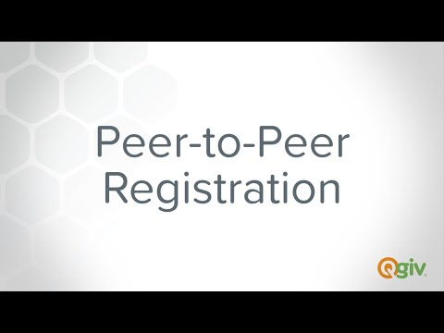](https://www.youtube.com/embed/VY4XPdJToFQ?feature=oembed)

<https://youtu.be/VY4XPdJToFQ>

**PENNY CAMPAIGN REGISTRATION:**

Visit this website link to get started: <https://secure.qgiv.com/event/2024pennycampaign/>.

First, click the **Register** link at the top of the event website.



To Start, you’ll decide **how you want to participate** – Click “As an Individual” or “Join or Start a Team.”

* **Individuals** will determine a fundraising goal and fill out the personal details form. Click “Complete Registration” at the bottom of the page.
* Those **Joining a Team** that has already been registered will search for the team leader’s name and click on that option.
* Those **Starting a Team** will click the “Start a New Team” button on the bottom right corner of the box.

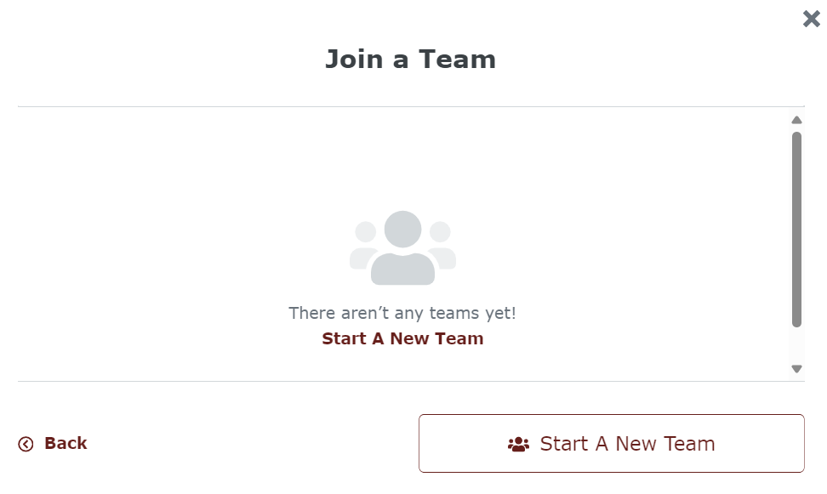

If you **Start A New Team**, you’ll choose the team's name and decide the team’s fundraising goal. You’ll also be designated as the team captain, which means you can edit the team’s fundraising page. Click “Save My Team”

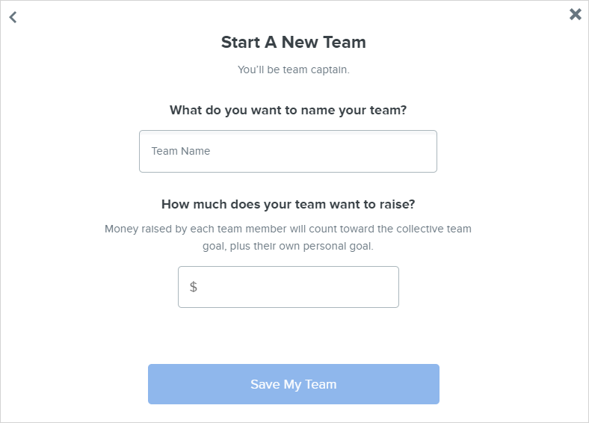

On the personal detailsform, you’ll determine your fundraising goal. If you’re part of a team, your personal goal will contribute to the team’s goal.

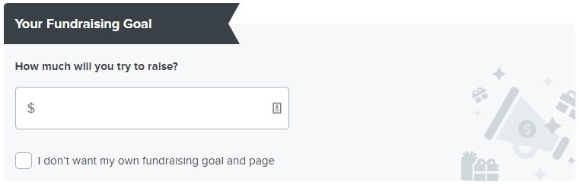

If you’d like to register for someone else, you can choose to **Add Another Participant** by clicking the button on the bottom left-hand side of the screen.

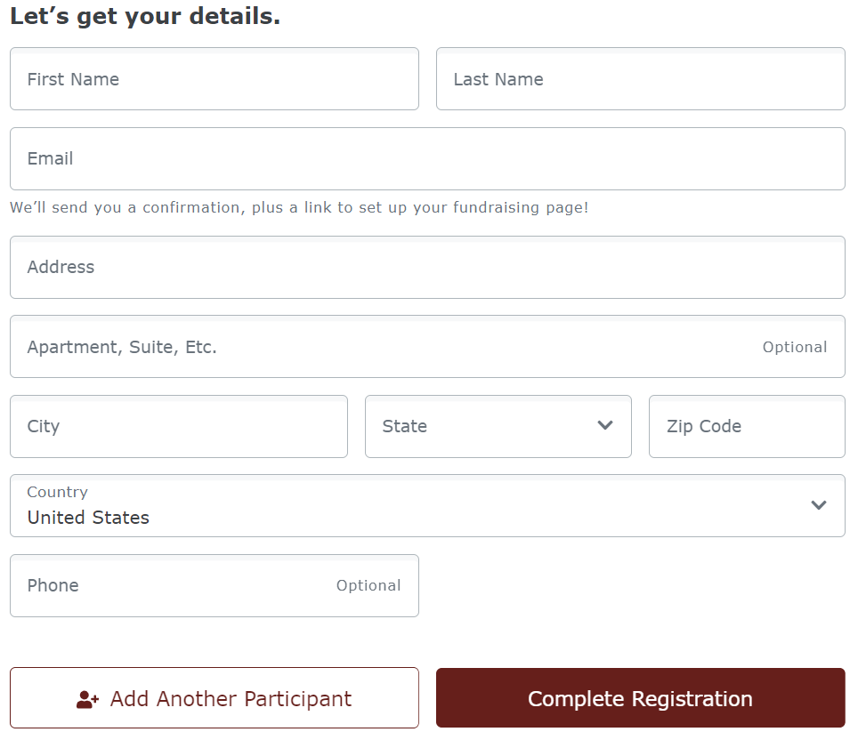

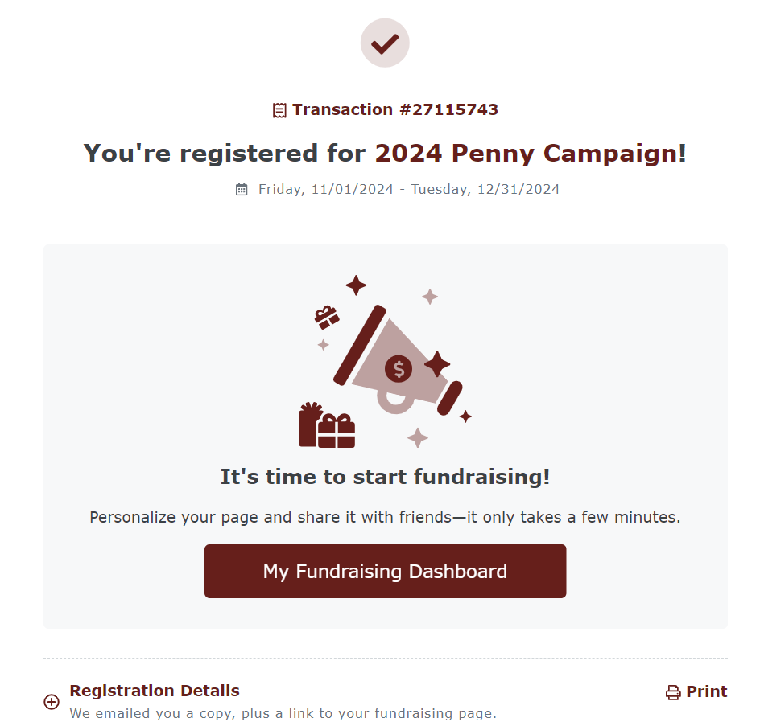Once you’ve completed registering, you will receive confirmation on the screen as well as a confirmation in your email inbox.

Click on “My Fundraising Dashboard” to customize your Participant Profile Page.

Click “Get Started” and change your profile picture. Go back to the “Complete Your Profile” box and press “Continue” to edit more items on your personal page.

The icons in the top-right corner of each widget will allow you to trash, hide, or change the settings. Click “Save Page” in the bottom left-hand corner

The bar at the bottom of the screen will guide you through the next steps: Send a Fundraising Email, Raise Your First Online Donation, Share on Facebook / X.

**MAKING A DONATION:**

If you choose to make a donation to the Penny Campaign, go back to the home page. Click the donate link in the menu bar at the top of the page.

Click on the amount you’d like to give and then choose whose fundraising efforts you’d like to support. If you don’t want to assign your donation to a fundraising team, just click “No one specifically, just the overall campaign” to give to the Penny Campaign.

Fill out the payment details and click “continue” at the bottom of the form to receive a confirmation of your donation!

Thank You, for registering to participate in the Penny Campaign! If you have any questions please contact Robin Stone at [robin.stone@samaritanforsyth.org](mailto:robin.stone@samaritanforsyth.org) or call 336-448-2664.