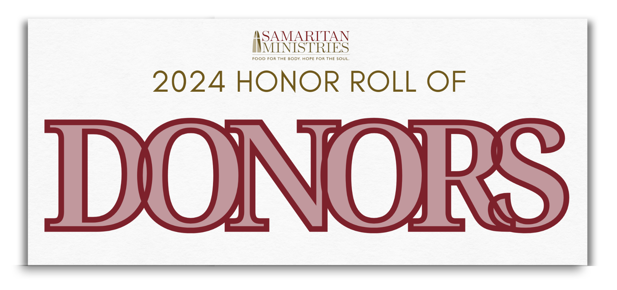

Tour de Llama

Presenting Sponsor: Arbor Investment Advisors

Platinum Sponsors
Jonathan and Jane Aves
Divine Llama Vineyards
Joe and Kathy Ely
Optimal Health Chiropractic, PLLC
Preferred Engineering, PLLC
Reynolda Equity Partners
West & Stem Architects

Gold Sponsors
Jerry and Janet Enos
Keith and Janet Huskins
Tom and Megan Lawson
Mike and Mary McCandless
Paul and Debbie Neil
River Oaks Community Church
Tanner and Meghann Robinson
Salem Gymnastics & Swim
Steen Valuation Group
Stewart
Dr. R. Bradley Thomason III
Richard and Allison Watts
Yes! Weekly

Silver Sponsors
Rick and Carol Atwater
Calvary Baptist Church
New Atlantic Contracting, Inc.
Nathan and Lisa Parrish
Ridge Care Senior Living
Teall Sports & Entertainment
Austin L. Temple, DDS
Wilson Covington Construction Co.
Windsor Commercial

Bronze Sponsors
Atwell Ford Real Estate
Bell, Davis & Pitt, P.A.
Brendle Crouse P.A.
Clyde and Ann Cash
Dairi-O, LLC
Fiddlin’ Fish Brewing Co.
Mike and Gayle Ford
Charles and Vicki Forrest
Gwyn Services
Johnson’s Modern Electric Co.
John and Mary Ann Justus
Brenda A. Kearney
River Birch Lodge
Viola Insurance Services
Dr. Cameron Williams

Special Thanks
Divine Llama Vineyards
Matt Canter, Ken’s Bike Shop
Michael West & Family
Event Volunteers
Deep Creek Friends Meeting
Prospect United Methodist Church
Fiddlin' Fish Brewing Co.

