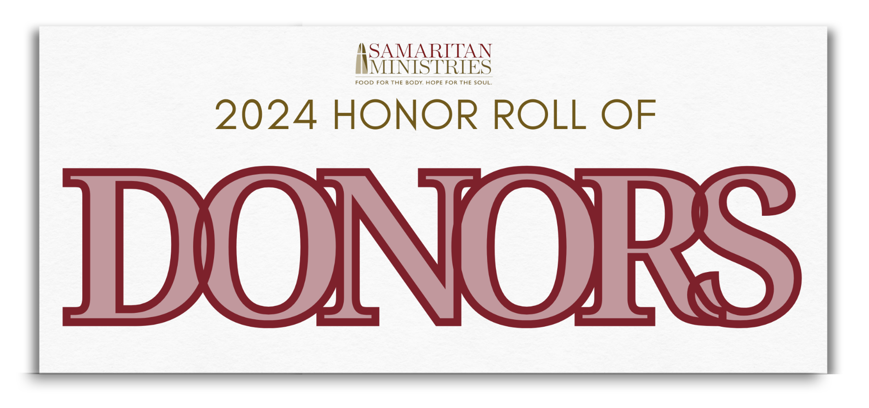

Civic, Corporate, Foundation & Government Donors

The Stimp Hawkins Society [$5,000+]
Arbor Investment Advisors
Bank of America Charitable Foundation
City of Winston-Salem Emergency Solutions Grant Funding
Deuterman Law Group, PA
FEMA
First Horizon Bank
First Horizon Foundation
Front Street Capital
Humana
The Leon Levine Foundation, Sandra and Leon Levine
McSwain Trust
NC Emergency Solutions Grant Funding
Novant Health
Richard W. Averill Foundation
Steen Valuation Group
The Strickland Family Foundation
The Winston-Salem Foundation, Albert L. Mitchell Fund
The Winston-Salem Foundation, Mary A. Payne Charitable Fund
The Winston-Salem Foundation, Samaritan Ministries Endowment Fund
The Winston-Salem Foundation, Shepherding Fund
The Winston-Salem Foundation, Sonjia Kurosky Project Cornerstone Endowed Fund
WXII 12

The Good Samaritan Society [Gold Level, $2,500-$4,999]
American Snuff Charitable Trust
The Budd Group
Comerica Bank
Five Points Capital Inc.
Flow Companies, LLC
Mt. Olive Pickle Co. Foundation
NC Super Source LLC
Optimal Health Chiropractic PLLC
Preferred Engineering, PLLC
The Sara Smith Self Foundation Inc.
Truist
West & Stem Architects
Williams Development Group
Womble Bond Dickinson

The Good Samaritan Society [Burgundy Level, $1,000 - $2,499]
Berkshire Hathaway | Carolinas Realty
Capture Public Relations & Marketing
First Bank
GEMCAP Development
Keith Smith Construction, LLC
Landmark Builders of the Triad
Mast General Store
Neighbors For Better Neighborhoods
New Atlantic Contracting, Inc.
New York Jewelry
Phi Beta Sigma Fraternity
Raytheon Technologies
Salem Gymnastics and Swim
Sam & Pam Hooker Foundation
Shelco, LLC
Stewart
T.J.M. Sales & Marketing, Inc.
Twin City Development Foundation
Viator Design & Construction
Wells Fargo Community Support
Winston-Salem Rotary Benevolent Fund

Friends of Samaritan [Patrons, $500 to $999]
Akerman LLP
Austin Temple & Katelyn Henderson DDS
Baird Foundation, Inc.
Bank of America Private Bank
Cassia Capital Partners
Deuterman Law Group, PA
Divine Llama Vineyards LLC
Duke Energy Foundation
F3
I.L. Long Construction Co., Inc.
Icon Builders
Impact Brands
Jean Pennybacker Memorial Fund
Lemmons Properties LLC
Mast Steel Structures LLC
Mi Pueblo, Inc.
Moorefield Engineering, P.C.
NAMI, NW Piedmont, NC
NTP/Premium 2000
Pinnacle Financial Partners
Ridge Care Senior Living
STITCH Design Shop
Tony Britt Spotter Charts, LLC
Wilson Covington Construction Co.
Windsor Commercial
Workplace Architecture + Design

Friends of Samaritan [Sustainers, $250-$499]
Atwell Ford Real Estate
Brendle Crouse, PA
Called To Bless
CVS Health
Dairi-O of King, Inc.
Delta Sigma Chapter of Phi Beta Sigma
E-stop
Frank Myers Investments LLC
Gwyn Services
Johnson's Modern Electric Co., Inc.
Reynolds American Foundation
Reynolds American Inc.
Storr Office Environments
TEGNA Inc.
Viola Insurance Services Inc.
The Winston-Salem Foundation
Z. Smith Reynolds Foundation, Inc.

Friends of Samaritan [Benefactors, $100-$249]
AbbVie Employee Engagement Fund
Akron Drive Pawn
American Family Mutual Insurance
Amgen Foundation
Blue Cross Blue Shield of North Carolina
Corvette Country
Delta Arts Center
Evangeline Rebekah Lodge #27, I.O.O.F.
G&G Forest Products
GE Aerospace Foundation
Guardian Life Corp.
Microsoft Corp.
NC Biotechnology Center
Parker Nursery
Quest Diagnostics
Sea Products Inc.
Thrivent Financial
Vulcan Materials Co. Mideast Division

Friends of Samaritan [Supporters, up to $99]
Bowen Town & Country Furniture Co.
Burger Barn of Union Grove
Cdw Corp.
Costco
Doud Building Supply Inc.
DTH Sales Inc.
Ecolab
Happy Destiny AA Group
Hearst
Leonard Ryden Burr
River Birch Lodge
Workday
WTOB
WXII 12

