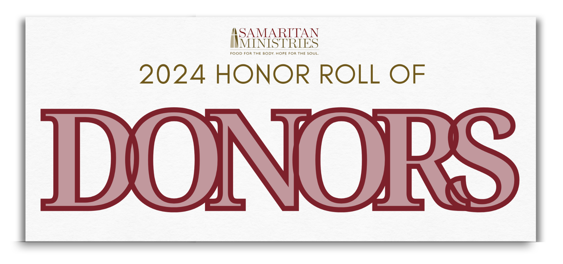

Churches
The Stimp Hawkins Society [$5,000+]
Augsburg Lutheran Church
Calvary Baptist Church
Centenary United Methodist Church
First Presbyterian Church
Highland Presbyterian Church
Holy Family Catholic Church
Home Moravian Church
New Philadelphia Moravian Church
Praise Assembly Church Ministries Inc.
River Oaks Community Church
St. Leo the Great Catholic Church
St. Paul's Episcopal Church
Two Cities Church

The Good Samaritan Society [Gold $2,500-$4,999]
Ardmore Baptist Church
Calvary Moravian Church
Clemmons Presbyterian Church
Evangelical Lutheran Church of the Epiphany
First Baptist Church on Fifth
Hope Presbyterian Church
Knollwood Baptist Church
Mt. Tabor United Methodist Church
Old Town Baptist Church
Pinedale Christian Church
Salem Presbytery

The Good Samaritan Society [Burgundy Level, $1,000 - $2,499]
Ardmore United Methodist Church
Awake Church
Clemmons Moravian Church
Discovery Class, New Philadelphia Moravian Church
Friedberg Moravian Church
Hopewell Moravian Church
Knights of Columbus, Santa Maria Council #2829
Main Street United Methodist Church
Manuel Sunday School Class, Sedge Garden United Methodist Church
Provisional Annual Conference of the NC Global Methodist Church
Olivet Moravian Church
Peace Haven Baptist Church
Philoptochos Society of Winston-Salem
Redeemer Presbyterian Church
United Metropolitan Missionary Baptist Church

Friends of Samaritan [Patrons, $500 to $999]
Christ Moravian Church
College Park Baptist Church
Family of Believers Ministry
First Christian Church of Winston-Salem
First Waughtown Missionary Baptist Church
Forsyth County United Usher Board Union
Fountain of Life Lutheran Church
Harmony Grove United Methodist Church
Heavenview United Pentecostal Church
Kingswood Church
Knights of Columbus, Holy Cross Council #8509
Messiah Community Christian Church
Mt. Carmel Missionary Baptist Church
Rural Hall Moravian Church Women's Fellowship
Saints Home United Methodist Church
Shallowford Presbyterian Church

Friends of Samaritan [Sustainers, $250-$499]
Center Grove Baptist Church / Faithful Followers
Clement Grove Church of God 7th Day
First Baptist Church on Highland Youth Ministry
Konnoak Hills Moravian Women's Fellowship
New Bethel Baptist Church
Reynolda Church
Salem Baptist Church
Sherwood Forest UMC United Women in Faith
Union United Methodist Church
United Cornerstone Baptist Church
Friends of Samaritan [Benefactors, $100-$249]
Ardmore Moravian Church - Circle 3
Bethany Baptist Church
Burkhead United Methodist Church
Clemmons Moravian Covenant Class
College Park Baptist - Ruth Class
Dellabrook Presbyterian Church
Faith Unity Missionary Church
Fraternity Church of the Brethren
Hickory Ridge United Methodist Church
Lula Street Church of God Missionary Department
Our Christian Heritage Church
Redeemed Missionary Baptist Church
Rural Hall Moravian Church
Salem Creek Friends Meeting
St. Andrew's United Methodist Church
St. Monica's Guild, St. Benedict the Moor Catholic Church
Trinity Sunday School Class, Mt. Tabor United Methodist Church
Union Ridge United Methodist Women
Unity Church of Winston-Salem
Woodland Baptist Church

Friends of Samaritan [Supporters, up to $99]
Advent-Hopewell Moravian Band
Crews Church Womens Circle
Emmanuel Baptist Church
Fairview Moravian Church
First Baptist Church on Highland
Forsyth Park Baptist Church
Lloyd Presbyterian Church
Mizpah Moravian Church
Mt. Tabor Circle 8
Phillips Chapel Missionary Baptist Church
Sherwood Forest United Methodist Church
Unity Moravian Church
Wesley Memorial United Methodist Church

