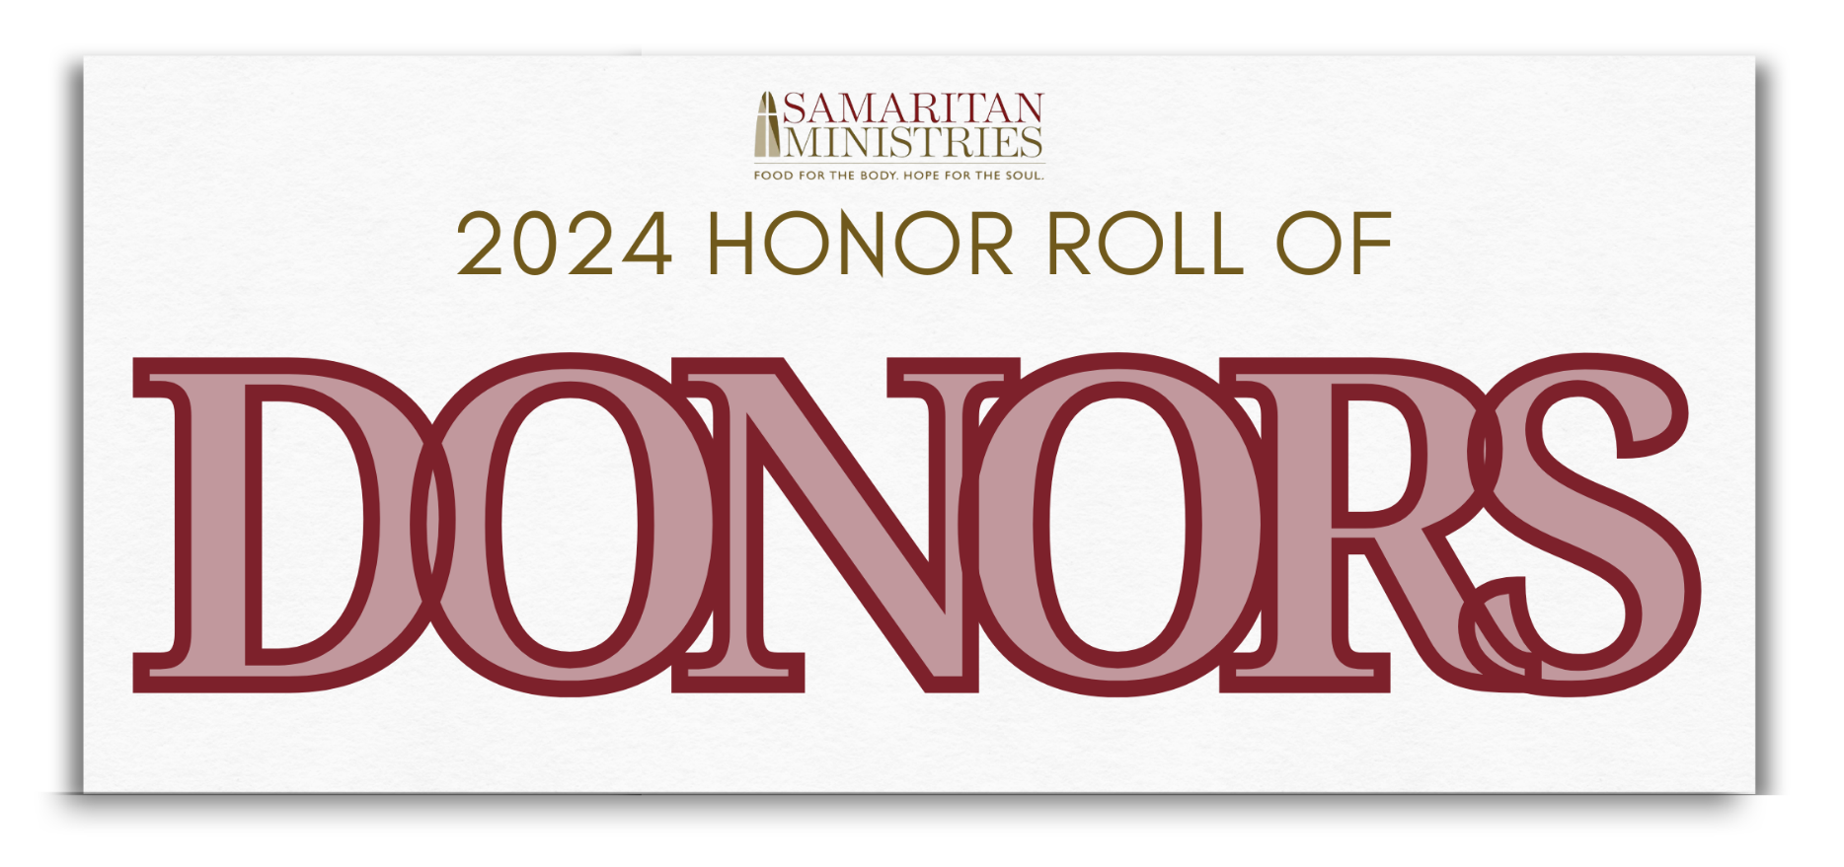

Gifts In-Kind
Season of Sharing
From Thanksgiving through New Year’ s, Samaritan Ministries celebrates the Season of Sharing a program that invites members of the community to share their time, talent and treasure with Samaritan guests in creative ways during the holidays. Participants included:

Ardmore Baptist Church donated socks, gloves and toboggans
Behind the Blue Line donated socks and wipes
Bethlehem Baptist Church donated food
Black Tigers Motorcycle Club donated canned food
Mr. & Mrs. Bill Blancato donated men’s fleeces and toothbrushes
Blessings Building Bridges donated food and laundry pods
Tylea Boyce donated food
Jamie Brewer donated Thanksgiving meals for guests
Bridge in the Gap Worldwide donated Christmas placemats
Ken Carlson Jr. provided Christmas party entertainment
Classic Packaging Co. did a Thanksgiving food drive
Mr. & Mrs. John J. Coiron donated underwear, toilet paper, shampoo and tissues
Cugino Forno donated a Christmas pizza dinner
Michael Davis donated coats
Emmanuel Baptist Church Men's Group provided hygiene bags for shelter guests
First Horizon Call Center did a food drive
First Presbyterian Church provided Christmas cards with bus passes for shelter guests
Debora Franklin donated crocheted soap bags
Essex & Virginia Glover donated food
First Baptist Church Caregiver’s Ministry donated socks, gloves, hats, etc.
Girl Scout Service Unit 144 donated hygiene items
Judy Hardy donated hamburger patties
Helping Hands & Paws did a food drive
Highland Presbyterian provided Christmas desserts
Jonathan Hughes
Barbara Kawecki donated knitted hats
KevMark Catering provided food
Legends Hospitality, Truist Stadium donated stuffing
Lindley Habilitation Services provided Thanksgiving bags and cards
Lloyd Presbyterian Church
Love Like Allyson donated socks
Greg McLeese donated coffee, deodorant, men’s thermal underwear
Meadowlark Middle School did a canned food drive and student tour
Messiah Moravian Church donated Love Feast Buns
Mi Pueblo donated a percentage of sales percentage on its 30th anniversary
Mike & Deb donated pound cakes
Sarah Murrell donated toothpaste and hygiene items
National Pen-Hellenic Council of Winston-Salem/Forsyth County donated Christmas cards
Novant Health did a Thanksgiving meal give-away
Novant Health Patient Access Department did a stocking drive & give-away for lunch guests
Melissa Parker donated hygiene items
Parkland High School JROTC group did a food drive
Jeff Peterson donated Christmas decorations
Professor A. Smellintime Soap donated handmade soap
Redeemer School donated Christmas bags
R. J. Reynolds High School B.E. YOU ERG did a winter item drive
RiverRun International Film Festival collected canned food donations at special Christmas film screenings
Mr. & Mrs. Jim Rosenberger donated Christmas hams
Salem Creek Friends Meeting donated brownies
Second Harvest Food Bank of NWNC donated food
Margaret Sehon provided 250 Christmas desserts
Shady Grove Global United Methodist Church provided bagged lunches
Daphne Sharpe donated Thanksgiving side dishes
SPARK held a coat distribution
St. Paul's Episcopal Church provided guest Christmas bags
St. Paul United Methodist Church donated men’s underwear
St. Timothy’s Women’s Shelter donated to-go lunch bags
Struggle Bus/Fannie Fleming did a winter item drive
Summit School donated food
Swing Phi Swing S.F.I. donated coffee and hygiene items
Gillian Thomas donated gloves, hats, tissue, lip balm
Triad Hindu Temple donated sandwiches
Truist donated food and toiletries
Two Cities Church donated Halloween candy and Thanksgiving placemats
Village Properties Triad did a Wish List item drive
Wake Forest Campus Kitchen donated food
Wake Forest University School of Medicine did The Giving Tree collection
Wake Forest University Delta Sigma Theta Sorority did a Breakfast Club food drive
Jeanne Weyant donated Christmas bags for residents
Winston-Salem First Seventh Day Adventist Church donated blankets
Winston-Salem Recreation & Parks hosted their annual Helping Hands & Paws collection drive to support Soup Kitchen and Shelter needs
Winston-Salem Forsyth County Transportation Department did a Stocking Drive for guests
WSSU - Phi Beta Sigma Fraternity, whose Homeless Awareness Week activities included a candlelight vigil, a tabling display, and the annual Sleep Out

In Kind Donors
Aaron-Elliott Locksmiths Inc.
Mackenzie Adams
Melanie Adams
Jailene Aguilar
Robert Anderson
Mark Andrews
Annunciation Greek Orthodox Church
Anonymous
Arbor Acres
Ardmore Baptist Church
Behind the Blue Line
Jan Berie
Bethlehem Baptist Church
Betty and Jim Holmes Food Bank Garden
Bishop McGuiness Catholic High School
Black Horse Studio
Black Tigers MC
Mr. & Mrs. Bill Blancato
Blessings Building Bridges
Josephine M. Bolling
Rob Boone
Tylea Boyce
Bridge in the Gap Worldwide
Charlene Brown
Doris Brown
Calvary Baptist Church
Calvary West
Camino Bakery
Catholic Charities
The Chronicle
City of Winston-Salem Employees
Clemmons Food Pantry
Clemmons Presbyterian Church
David Cline
Mr. & Mrs. John J. Coiron
College Park Baptist Church
Coptic Orthodox Church
Mr. Matthew Cosgrove
Costco
June Crappe
Crisis Control Ministry
Crumbl Cookies
Cugino Forno WS LLC
Mr. & Mrs. David Cuthrell
Michael Davis
Davis Sign Company, Inc.
Marsha Deem
Deeya Global Foundation
Diamondback Grill
Divine Llama Vineyards
Mr. & Mrs. Julian C. Drake
Mr. & Mrs. Dutko
Dick & Ellen Egloff
Enterprise Center
Evangelical Lutheran Church of the Epiphany
Evergreen Garden Club
Fairview Moravian Church
Faith United Methodist Church
Julie Fields
First Bank - Peters Creek
First Baptist Church Caregiver's Ministry
First Baptist Church on Highland
Fannie Fleming
Rosemarie Fleming
Flow Companies, LLC
Food Deals Supply
Food Lion
Forsyth Country Day School
Forsyth County Government
Deborah Franklin
The Fresh Market
Friendship Baptist Church
Drs. Sanjay & Lauren Gandhi
Mr. & Mrs. Michael Garner
Amy Gary
Girl Scout Service Unit 144
Essex & Virginia Glover
Fresh Market
Golden Corral
Gospel Light Christian School
Greater Higher Ground Ministries
Chris Green
GreeNest
Leigh Hammond
David Hardison
Judy Hardy
Harmony Grove United Methodist Church
Timothy Hart
Highland Presbyterian Church
Warren Hill
William E. Hollan, III
Holy Family Catholic Church
Home Family
Hope Moravian Church
Hopewell Moravian Church
Jonathan Hughes
Marvin James
Mr. & Mrs. Larry Joe
Christine Jones
Junior League of Winston-Salem
Kappa Alpha Psi Folundation
Barbara Kawecki
Keep Winston-Salem Beautiful
Ken’s Bike Shop
KevMark Catering
Mary King
Knights of Columbus, Bishop Greco Council #9499
Henry Lee
Legends Hospitality, Truist Stadium
Lindley Habilitation Services
Living Life In Pink
Lloyd Presbyterian Church
Lowes Foods
Clinton Mack
Rev. Dr. Francis S. Manns, Jr.
Sylvia Martin
Marvin United Methodist Church
Odell Mason
Greg McLeese
Messiah Moravian Church
Millennium Center
Nona Miller
Minglewood Farm and Nature Preserve
Mocks United Methodist Church
Morning Star Missionary Baptist Church
Beth Morphis
Morris Chapel United Methodist Church
MRF Deli Provisions Inc.
Mt. Tabor United Methodist Church
David & Kathy Murray
Sarah Murrell
Ebony Myles
National Pan-Hellenic Council of WS/Forsyth
NC Museum of Art/SECCA
New Communion
New Philadelphia Moravian Church
Mr. & Mrs. Paul Nielson
Novant Health
Mr. & Mrs. John M. Olenick
Olivet Moravian Church
Order of Malta
Stephen N. Paige
Panera Bread
Parkland High School
Parkview Church of God
Nirat Patel
Dorothy Patterson
Lucy Paynter
Peace Haven Baptist Church
Melissa Penland
Jeff Peterson
Professor A. Smellintime Soap
Purple Crow
Red Bank Baptist Church
Redeemer School
Reynolds American Inc.
Reynolds High School
River Oaks Community Church
Don Roberson
Robin Brown Designs
Audria Robinson
Mr. & Mrs. Jim Rosenberger
Saints Home United Methodist Church
Salem Creek Friends Meeting
Salemtowne Retirement Center
Salvation Army
Second Harvest Food Bank of NWNC
Mr. & Mrs. Scott Semke
Seventh Day Adventist Church
Shady Grove Global United Methodist Church
Brandon Shanahan
Daphne Sharpe
Cassandra Shavers
Shekinah Glory Family Life Center
Shizzy's Wildcat Rescue
Society of St. Andrews/Durham
St. Andrew's United Methodist Church
St. John's Lutheran Church
St. Leo the Great - Grade School
St. Leo the Great Catholic Church
St. Leo’s Men’s Group
St. Paul United Methodist Church
St. Stephen's Missionary Baptist Church
Summit School
Sutton Brothers Service and Repair
Dr. & Mrs. David W. Swayne
Swiftwater Media, LLC
Swing Phi Swing S.F.I.
Target
Temple Emanuel
Temple of Glory
Gillian Thomas
Josetta Timberlake
Tony's Fine Tastes
Triad Adventist Fellowship
Triad Fellowship
Triad Hindu Temple
Truist
Twin City Kiwanis Club
Two Cities Church
Union Baptist Church
United Soccer
Pearlie Vance
Wake Forest Campus Kitchen
Wake Forest University
Wesley Memorial United Methodist Church
West Side Baptist Church
WestRock
Jeanne Weyant
Whole Foods
Diana Widmer
Cindy Wiles
Kevin Williams
Winston-Salem First Seventh Day Adventist Church
Winston-Salem Journal
Winston-Salem Rescue Mission
Martha Wood
Miss Regina Woodberry
WS/FCS Virtual Academy
Mr. & Mrs. Steven John Zitta


