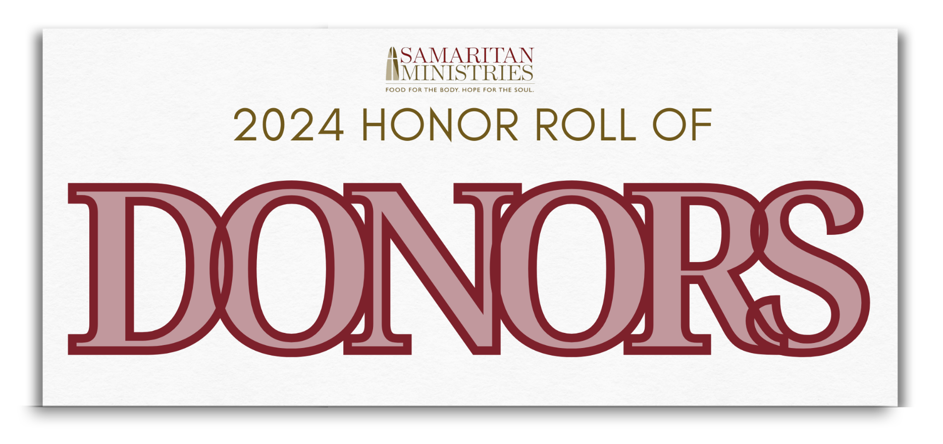

SAM & Eggs
Stimp Hawkins Sponsors
Front Street Capital
Keith & Janet Huskins*
Landmark Builders
Bill & Kim Means
The Robinson Private Client Group of Oppenheimer & Co.
Two Cities Church

Benefactor Sponsors
Jonathan & Jane Aves*
The Budd Group
Comerica
Mark & Susan Doughton*
Joe & Kathy Ely*
First Horizon*
Flow Companies
Highland Presbyterian Church
David & Kathy Murray*
Novant Health
Steen Valuation Group
Wynn Tanner*
Dr. R. Bradley Thomason III
The Tierney Family
Richard & Allison Watts
Williams Development Group
Winston-Salem Journal
Womble Bond Dickinson

Friends of Samaritan Sponsors
Arbor Investment Advisors
Bo & Kathy Brookby*
The Chronicle
Jerry & Janet Enos*
First Bank
Mike & Gayle Ford*
Gemcap Development
Tom & Megan Lawson
Tom & Annie McKiernan
Paul & Debbie Neil*
Doug & Leila Punger*
River Oaks Community Church
Jose & Silvia Rodriguez*
Tim & Carolee Ronan*
Salem Investment Counselors
Shelco
Dr. Pat Stuart
West & Stem Architects

Table Sponsors
Akerman
Baird Private Wealth Management
Bank of America Private Bank
Paul Breitbach & Steve Viola*
Capture Public Relations & Marketing
Ken and Melanie Carlson
Clyde & Ann Cash
Cassia Capital Partners, LLC
Clemmons Presbyterian Church
F3
Dexter A. Felder
Charles & Vicki Forrest*
Robert & Sheila Garcia
I. L. Long Construction Co., Inc.
Icon Custom Builders
Impact Brands
The Rev. Donald & Denise Jenkins*
John & Mary Ann Justus*
Dan & Bonnie Murphy
National Truck Protection
Sylvia and Terry Oberle*
Nathan & Lisa Parrish*
Robert Parsley/Young Samaritans*
Chuck & Lucie Patton
Peace Haven Baptist Church
Pinnacle Financial Partners
Scott & Jean Anne Semke
Stitch Design Company
Teall Sports & Entertainment
Tony Britt Spotter Charts
Truist
Two Cities Church
United Community Bank
Kelly & Susanne Wilkinson*
Workplace Architecture & Design

Table Captains
Paul Breitbach/Steve Viola
Carolyn Britt
Ned Erickson
Emma Gillett/Young Samaritans
Jim & Beth Graham
Brenda A. Kearney
Reid & Hannah Palmer/Young Samaritans
Charlesetta Taylor

*Sponsors who also served as a table captain

Special Thanks
Lanie Pope, Chief Meteorologist at WXII-TV12
Swiftwater Media
Benton Convention Center Team
Event Volunteers

