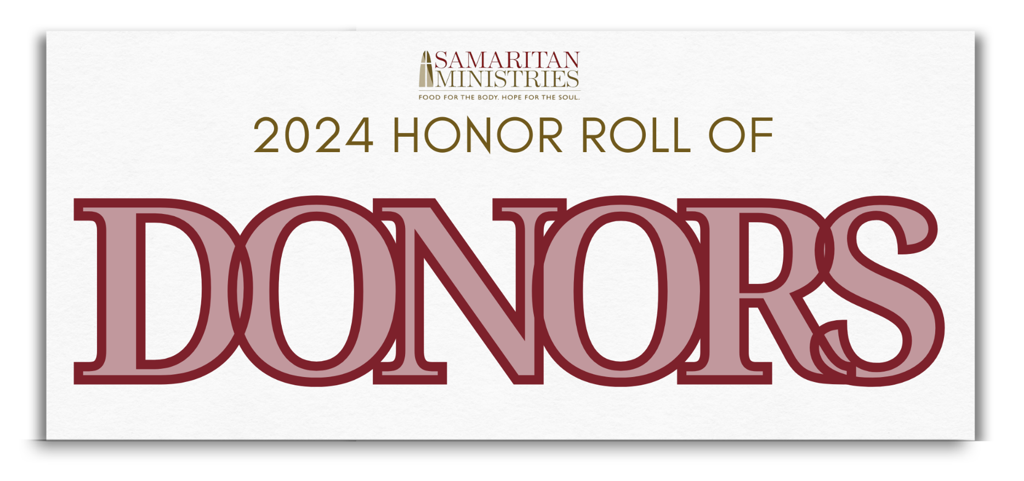

Sponsors
Deuterman Law Group
First Horizon
David & Kathy Murray
Winston-Salem Journal
WXII-12

Honorary Chair
Lanie Pope, Chief Meteorologist at WXII

Location
Truist Stadium - Home of the Winston-Salem Dash

Online Penny Campaigners
Some formed a team, while others raised money as individuals
Participant | Team
Kayleigh Armentrout | Team Deuterman Law
Sonia Beckford* | Taste Jamaica Food Truck
Kyle Caudle | First on Fifth
Willie Conner* | Phi Beta Sigma Fraternity, Inc.
Precious Crews* | South Fork Elementary
Rese Davis
Courtney Dawkins* | Summit School 3rd Grade
Maurice Douglas* | Moe's Angels
Carolyn Ely
Emma Gillett* | Young Samaritans
The Go-To Winston-Salem* | The Go-To Winston-Salem
Sean Hawkins | Phi Beta Sigma Fraternity, Inc.
Jan Kelly | Samaritan's Team
Alexis Michelle* | Parkland High School - Senior SLC
Kathy Murray* | Hopeful Hearts 2024
Maureen Olsen* | Team Deuterman Law
Meredith Parker* | First on Fifth
Lisa Parrish
Robert Parsley | Young Samaritans
Jordan Rucker | Phi Beta Sigma Fraternity, Inc.
Justin Rucker | Phi Beta Sigma Fraternity, Inc.
* Team Captain

Donors
Because of the nature of Penny Campaign, we are not able to identify all donors,
but we are grateful to all who donated. Every penny counts and makes a difference.
Churches & Church Groups
Ardmore Moravian Church
Centenary United Methodist Church
Clemmons Moravian Covenant Class
Emmanuel Baptist Church
Fairview Moravian Church
Faith Unity Missionary Church
First Baptist Church on Fifth
First Baptist Church on Highland
Youth Ministry, First Baptist Church on Highland
First Waughtown Missionary Baptist Church
Forsyth Park Baptist Church
Fraternity Church of the Brethren
Galilee Missionary Baptist Church
Harmony Grove United Methodist Church
Jared's HOPE
Kingswood Church
Knights of Columbus, Our Lady of Mercy
Konnoak Hills Moravian Women's Fellowship
Lloyd Presbyterian Church
Manuel Sunday School Class, Sedge Garden United Methodist Church
Maple Springs Baptist Church
Mars Hill Baptist Church
Marvin United Methodist Church
Messiah Community Christian Church
Mizpah Moravian Church
Mt. Carmel Missionary Baptist Church
New Bethel Baptist Church
New Hope Ministry
New Philadelphia Moravian Church
Peace Haven Baptist Church
Phillips Chapel Missionary Baptist Church
Pine Chapel Moravian Church
Redeemed Missionary Baptist Church
River Oaks Community Church
Rural Hall Moravian Church
Salem Baptist Church
Sherwood Forest United Methodist Church
St. Monica's Guild, St. Benedict the Moor Catholic Church
St. Timothy's Episcopal Church
Union Chapel Baptist Church
Union Cross Moravian Church
Children's Ministry, United Metropolitan Missionary Baptist Church
Unity Moravian Church
Businesses, Civic Groups, Schools
A Better World Learning Center
Berkshire Hathaway | Carolinas Realty
Brunson Elementary School
Called To Bless
Capture Public Relations & Marketing
Carter High School
Clemmons Elementary School
Clemmons Middle School
Craige Jenkins Liipfert & Walker LLP
E-stop
First Horizon Foundation
Front Street Capital
Gibson Elementary School
Griffith Elementary Pre-K
Hanes Magnet School
Kingswood School
La Petite Academy
Meadowlark Middle School
Mi Pueblo, Inc.
New York Jewelry
Old Richmond Elementary School
Parkland High School
Pfaff's, Inc.
Phi Beta Sigma, Delta Alpha Chapter
Phi Beta Sigma, Delta Sigma Chapter
Rural Hall Elementary School
South Fork Elementary School
Steen Valuation Group
Stone Soup Vintage
Summit School
Sunnyside Ministry
The Academy at Middle Fork
Vienna Elementary School
Wake Forest School of Medicine
Wayne AA Group
West Forsyth High School
Individuals
Dr. Betty Acey Alexander
Mr. & Mrs. David Alexander
Heinz Altmann
Gail Arnette
Dr. & Mrs. Sam T. Auringer
Vonda Baggett
Mr. & Mrs. Mark Barkley
Elaine M. Bates
Christy Bellis
Robin Benfield
Irma Berry-Scott
Jeff & Kim Blevins
Jennifer Bottoms
Jim Bower
Mr. & Mrs. Larry Bower, Jr.
Wayne Bowles
Carolyn Britt
T.L. Brown
Douglas Brule
Ann Doherty & George M. Bryan, Jr.
Barry Bryant
Kenwyn Caranna
Ty & Nancy Carson
James Carter
Syreeta Carter
Melanie Clifton
Mark & Deb Clinard
Mr. & Mrs. Jason Cogdill
Mr. & Mrs. John J. Coiron
Don Collins
Ronnie Comer
Virginia Cooper
Lilley Covington
Mr. & Mrs. John L. Crabbe
James Crawford
Charlie Crotts
Melissa Cullen
Alice Cunningham
J. Carlton & Ruth Deaton
Dr. Nancy Denizard-Thompson
Judson Deramus
Pat Dewan
Jerry Dietsche
Mr. & Mrs. Richard Dissosway
Malik Douglas
Maurice Douglas
Micah Douglas
Mr. & Mrs. Ray Eaton
Carolyn M. Ely
Jerry & Janet Enos
Mrs. Rosemary Enos
Robert W. Fisher
Mr. & Mrs. Mike Ford
Mr. & Mrs. Charles Forrest
Maria & Jeff Fritts
William F. Fulton
Rod Gainsford
Joy Gambill
Joshua Gardner
Mr. & Mrs. John Gardner
Janice Garling
Michael Gendy
Emma Gillett
Mr. & Mrs. Roosevelt Givens
The Go-to Winston-Salem
Peggy & Thurmond Griffith
Tom Griffiths
Teresa Grossi
Mr. & Mrs. Daniel J. Guyer
James Hall
Mr. & Mrs. Robert Halsey
Anita Hamby
Rebecca Haney
Suzanne Hanna
Mr. & Mrs. Dean Harris
Sean Hawkins
Mr. & Mrs. Keith Herndon
Elizabeth Hobert
Gary Hoosier
Lana Howard
E.A. and Gerri Hoyle
Mr. & Mrs. Lawrence E. Hudspeth
Keith & Janet Huskins
Judy Hutt
Ms. Irma B. Jackson
Donnie James
Rob & Errika Jenkins
Shakira Jenkins
Victoria Johnson
Jen Jones
Kevin Jones
Mr. & Mrs. John Justus
Mr. & Mrs. Jack Kavanaugh
Mr. & Mrs. David Alan Keely
Mr. & Mrs. Philip Davis Kelley
Jan Kelly
Mr. & Mrs. Cameron Kent
John Kepins
Rebecca King
Mr. & Mrs. Philip G. Kinken, Jr.
Mr. & Mrs. F.E. Kinnett
Phillip Langeberg
Walter & Patricia Lassiter
Debbie Lawrence
Marcia Lewis
Sydney Lewis
Dr. Larry D. Little
Jennifer Lockert
Gail S. Marion
Mr. & Mrs. Tony Marion
Justin Martin
Ruth Mathis
Mr. & Mrs. G. Eric Matthews
Chris May
Mr. & Mrs. Gary McCoy
Ruth McHenry
Saundra McIver
Mary Anne Merritt
Joni Messer
Dr. & Mrs. Joseph Middleton
Mr. & Mrs. Aneil Mishra
Mr. & Mrs. Patrick J. Mogon
Dan Monroe
Mr. & Mrs. David Murray
Mr. & Mrs. Paul E. Neil, III
Sherrie Newton-Mullis
Siham Ott
Mr. & Mrs. Paul Ouellette
Nathan & Lisa Parrish
Mr. Jerry Pate
Jim Patten
Steve & Linda Patterson
Mr. & Mrs. James E. Peacock, Jr.
Yvonne Pelkey
Candace Perryman
Mary Jane Pishko
Lynn Pitson
Connie Powell
Charles Pruitt
Elizabeth Raney
Kevin Ratliff
Owen Ray
Bernardine Rea
Dianna S. Read
Claudia D. Richardson
Aletha Ritchey
Renee Roach
Mr. & Mrs. Jose Ramon Rodriguez
Mrs. Sara Romanik
Mr. & Mrs. Jim Rosenberger
Jannell Rowe
Gwendolyn Russell
Steve & Betty Russell
Pete Schantz
Rosalyn G. Schmidt
Mr. & Mrs. Scott Semke
Ryan Serksnas
David Shaffner
TyKeia Slade
Eleanor S. Smith
Mr. & Mrs. Tom Smith
Wayne Lewis Smith
Christina Solano
Mr. & Mrs. Mark Spittle
Billy Stewart
Mark Stewart
Preston Stockton
Mrs. Pat Stoeber
Robin Stone
Cindy Stubblefield
Patricia Stultz
Kaylynn Suttles
Angela Taylor
Rick Tesh
Dr. R. Bradley Thomason III
Chervonne Thompson
Patricia Thompson
Mr. & Mrs. Alphonzo D. Vance
Gregg Vogelsmeier
Barbara & Russ Vroom
Lisa & Davis Vu
Nancy & Walter Waldspurger
Debra O. Wall
Janet Myrick Wall
Richard & Allison Watts
Lakesha Weston
Mae White
Mr. & Mrs. Len White
Mr. & Mrs. Jason Whitener
Mark Whittington
Dr. Cameron Williams
Jeanette Wilson
Samuel Wilson
Janice M. Wright-Prince
Rena Yates & Aron Vaughn



